Agenda

*Date: 01/25/14*

*Location: Brody Collaborative Space - Room 1045 and 1042*

*Actual Time: 1 pm - sometime*

*Planned Length: a while*

***Silly Picture of the Week:***

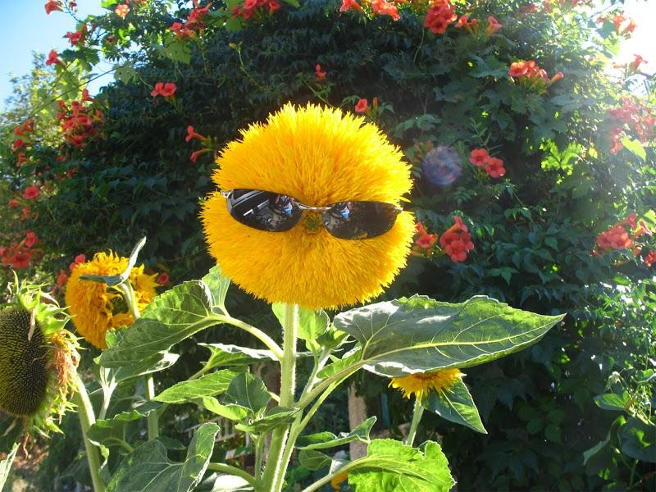

***Please add and comment on anything and everything in the agenda!***

|  |  |  |  |
| --- | --- | --- | --- |
| **Team Member(s)** | **Topic** | **Time** | **Goals** |
| ~~Anyone~~ | ~~Announcements~~ | ~~5 min~~ | ~~If any new developments have occurred the team is updated on them~~ |
| ~~Shannon~~ | ~~Team Bonding~~ | ~~15 min~~ | ~~Decide on a~~ *~~definite~~* ~~team bonding activity and schedule a~~ *~~definite~~* ~~time~~ |
| ~~Team Leads~~ | ~~Jose~~ | ~~2 min~~ | ~~Figure out what Jose is supposed to be doing/updated on~~ |
| Steven, John, ~~Mark*~~, and Rolando | Front End | A while | Figure out rectangly things, do awesome stuffz |
| Xiaomeng, Brian, and Si | Develop corner cases | 30 min | On the shared document list all corner cases for resetEyes in 4 columns: Description, Input, Expected behaviour, and Actual Behaviour |
| Xiaomeng, Brian, and Si and Front End | Figure out which corner cases are unnecessary | 15 min | Cross off any cases that are guaranteed to never occur and therefore unnecessary to test |
| Xiaomeng, Brian, and Si | Split up cases amongst yourselves and begin testing | 5 min | Everyone is assigned some cases to tests and begins testing, filling out the shared doc |
| David and Brian | Strabismus Detection | A while | Turn psuedocode into real code; get the code to compile; run; test |
| Shannon and Shumin | Machine Learning Research | 45 min | Research machine learning and develop hyperopia/myopia/amblyopia psuedocode or real code; or a list of questions if it’s still confusing |
| Arvind and Andrew | Hardware | a while | Fill out order form for bracket; add price to budget(if we haven’t turned that in yet); make plan for getting lots of red eye photos (day/time/location/publicity/recruiting people) |
| Shannon | Recap and Next steps | 5 min. | Meeting progress/ goal accomplishment is recapped. Next steps are outlined so that every team member goes into next week knowing what they are expected to contribute |

# Notes

*Mark has a cold and will not be able to attend

Mira Mesa Bowling for team bonding

$18 per lane* 3 lanes = $54

shoes are $3.50 per person

Mira Mesa bowl

February 8th at 3pm is the day/time for team bonding

List of people to attend:

1. Brian
2. Si
3. Brian
4. Shannon
5. John
6. Shumin
7. Steven
8. David
9. Xiaomeng
10. Arvind
11. Andrew
12. JT
13. Mark
14. Andreas

reserve 3 lanes

3 pm mira mesa lanes

<http://www.miramesalanes.com/>

bring socks

Brian will text people and ask if they can attend. After we have a definite number of people we should call and make a reservation.

# Summary

# TODO

* Reserve team bonding lanes at the bowling alley on Wednesday

# Whiteboard Pics

# Useful Links

Front-End Frame Documentation: <http://docs.wxwidgets.org/2.8.11/wx_wxframe.html#wxframe>

Dropbox: <https://www.dropbox.com/sh/8nsmamaiklpvr9l/Fo5xgv4ogH>

<http://scrumy.com/DVSWinter2014>

Machine Learning:

* <http://www.quora.com/What-are-some-good-resources-for-learning-about-machine-learning-Why>
* <http://www.youtube.com/playlist?list=PLD0F06AA0D2E8FFBA&feature=plcp>
* http://scikit-learn.org/stable/tutorial/basic/tutorial.html

<http://pediatrics.aappublications.org/content/122/6/1401.full.pdf>

http://one.aao.org/Flash/VisionScreening/flashfiles/bruckner.swf